Deploying a MERN Stack Application on AWS using Terraform and Ansible:

Assignment Objective
The objective of this assignment is to gain practical hands-on experience in deploying a MERN stack application on AWS using Infrastructure as Code (IaC) with Terraform and configuration management/automation using Ansible.
The assignment covers the following major areas:
- AWS infrastructure provisioning using Terraform
- VPC and networking configuration
- Public and private subnet configuration
- EC2 instance provisioning
- Security group configuration
- Application environment setup
- Ansible-based server configuration and application deployment
- Deployment of the MERN stack application
- Testing and validation of the deployed application

Technologies:
Layer | Technology
Cloud | AWS
Infrastructure | Terraform
Configuration | Ansible
Frontend | React
Backend | Node.js + Express
Database | MongoDB
Web server | Nginx
OS | Ubuntu 24.04 LTS
Network | VPC, Public/Private Subnet
Internet | Internet Gateway
Private outbound access | NAT Gateway
Security | Security Groups + UFW + SSH
SSH | EC2 Key Pair
Repository | GitHub
Project Structure: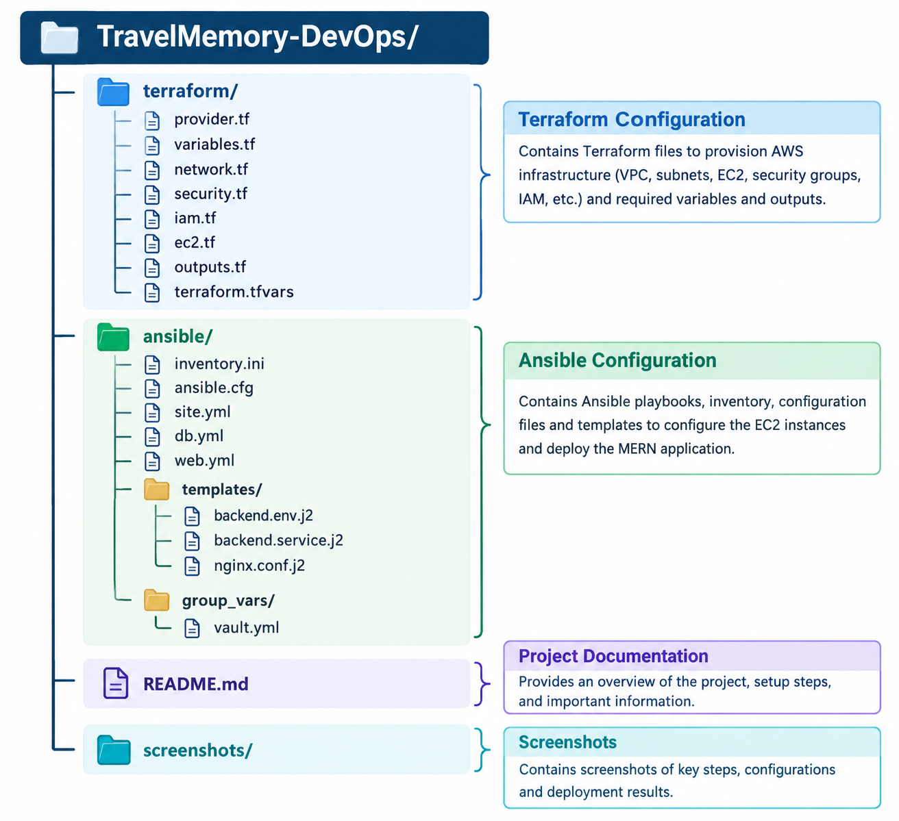
Software Installation :
- Using PowerShell/Command Prompt
- AWS CLI Configured
- Terraform Installed
- Ansible installed
- PPK created from PEM file
- SSH key configured and connected in PowerShell
Now I have completed all the above steps and going forward to follow below Architecture for VPC, Route Table, NAT Gateway, Security Groups etc.
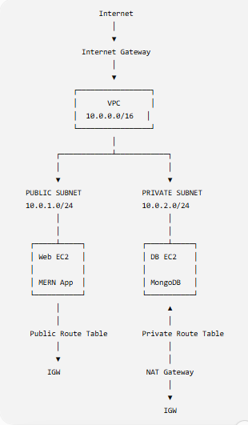

Terraform Resource flow :
- VPC ->
- Public Subnet ->
- Private Subnet ->
- Internet Gateway ->
- Public Route Table ->
- Public Route ->
- Associate Public Subnet ->
- Elastic IP ->
- NAT Gateway ->
- Private Route Table ->
- Private Route → NAT Gateway ->
- Associate Private Subnet ->
- Security Groups ->
- EC2 Instances

Create the Project Directory/Folder for Terraform :
- mkdir -p ~/TravelMemory-DevOps
- cd ~/TravelMemory-DevOps
- mkdir terraform ansible
- mkdir -p ansible/templates
- mkdir -p ansible/group_vars
- mkdir screenshots
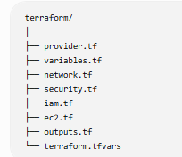
Then I have created all the Above file with the code for Terraform.
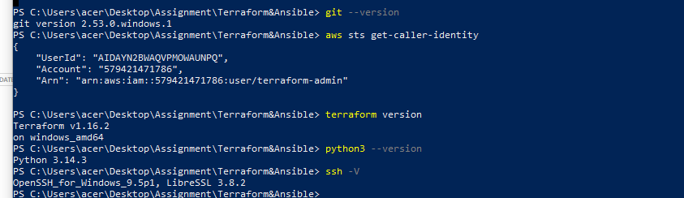
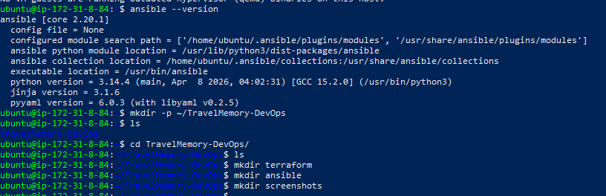
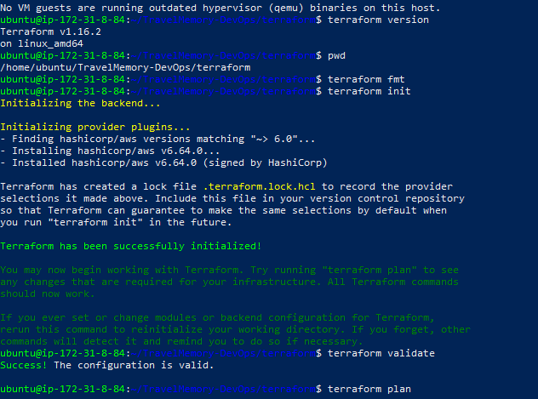
After that, I have created VPC, Internet Gateway, Route Table Public & Private, NAT Gateway, Security Groups etc. See Screenshots for Ref.
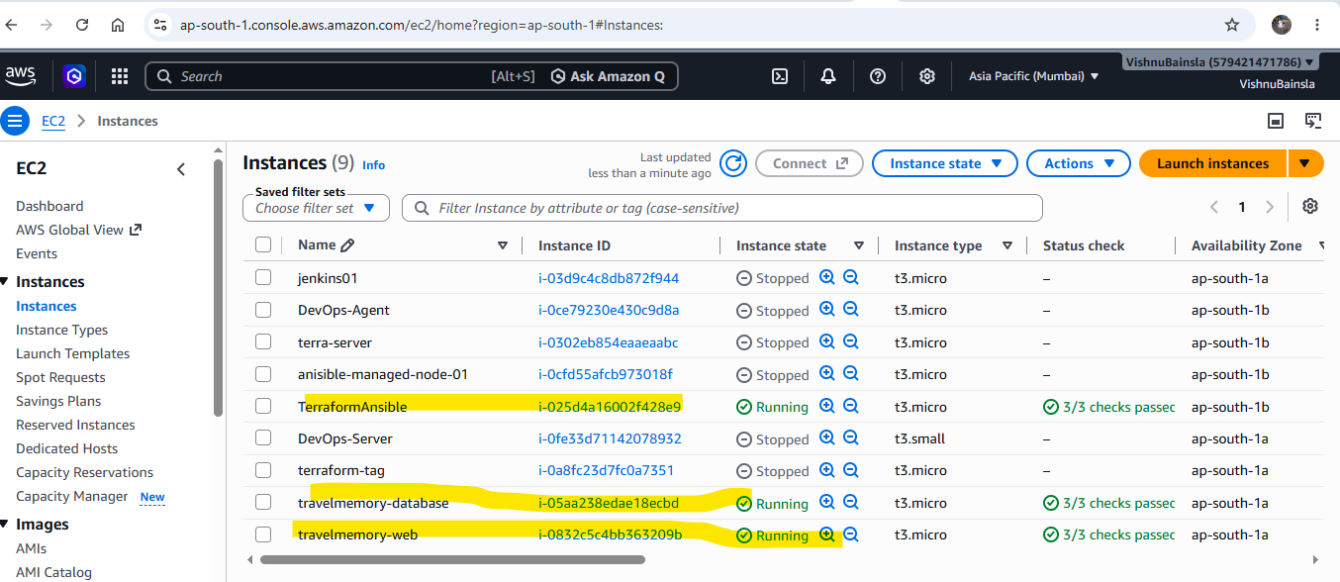
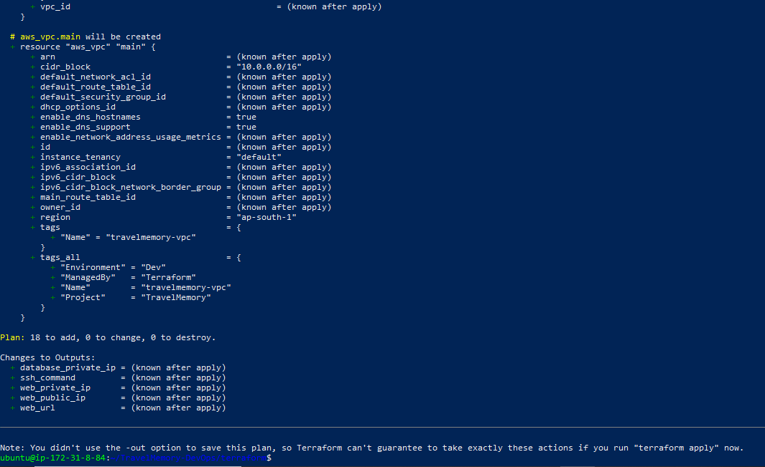
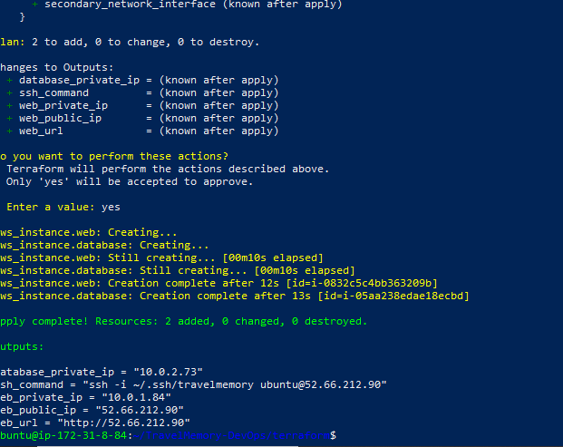
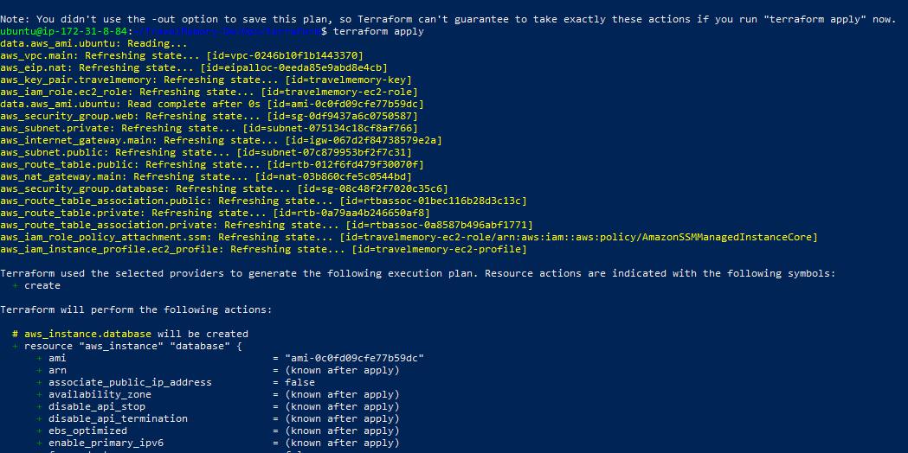
Also Created the IAM user :
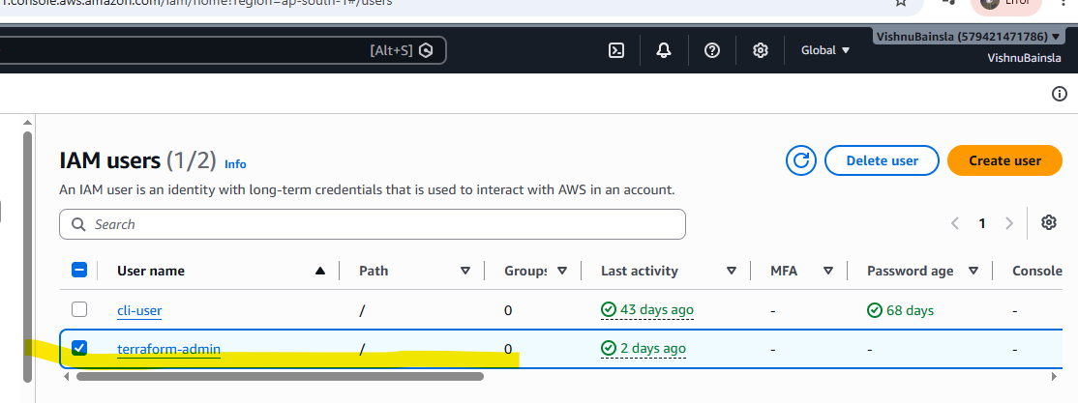
I have Successfully Run the Terraform fmt , terraform init, terraform Plan, Terraform Apply / see the screenshot for Ref.
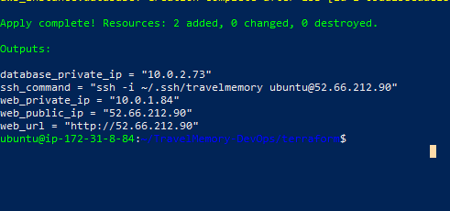
Then Test Web EC2 SSH and Test database connectivity from web server:
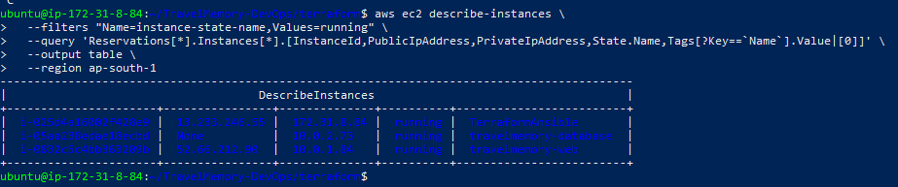
After that, I have Configured the Ansible and get the Terraform IP Address:
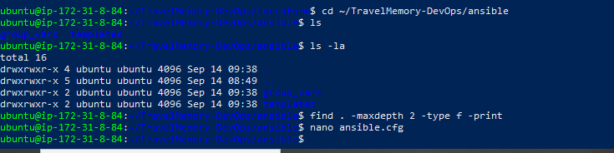
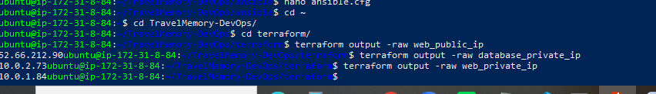
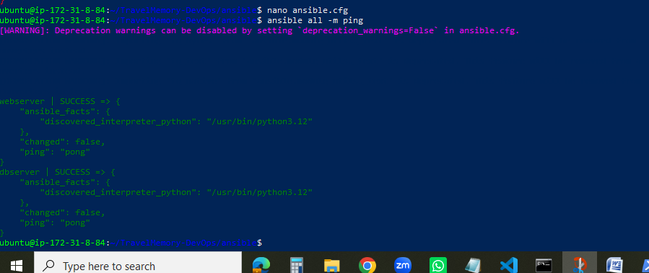

Then Created the Ansible Inventory and Test Ansible Connection. See Ref
Now Installed the MongoDB and created its Password:
- cd ~/TravelMemory-DevOps/ansible
- mkdir -p group_vars
- Use MongoDB Playbook
- 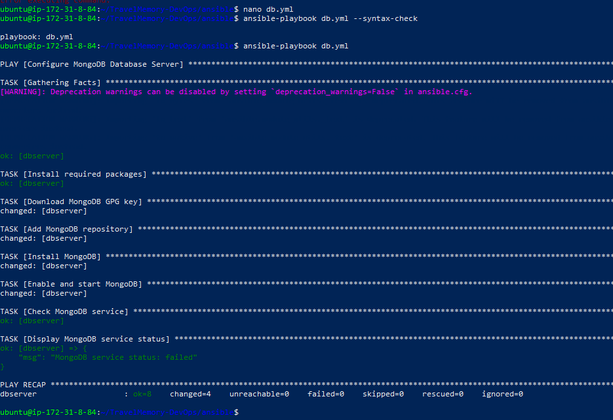

- Run the MongoDB Playbook
- 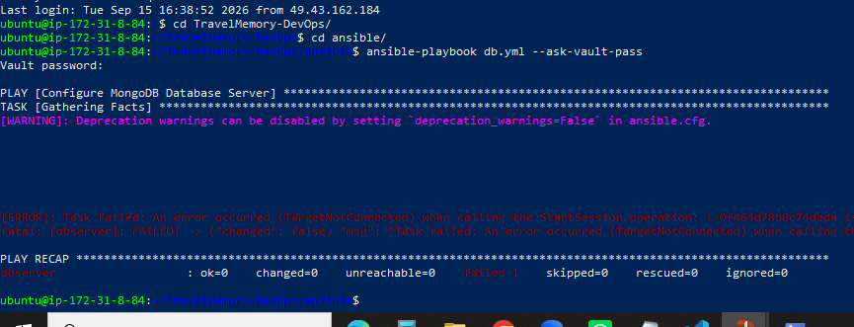

- Verify the MongoDB Playbook

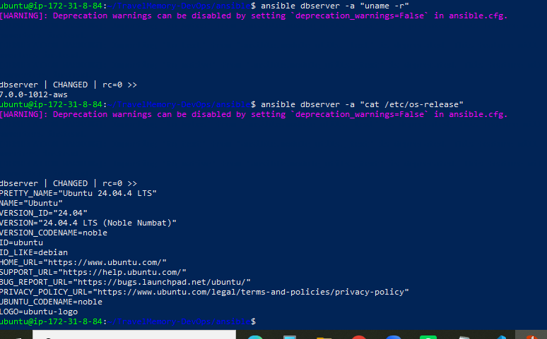
MongoDB's official Ubuntu instructions use the official mongodb-org repository, and MongoDB warns that authentication and network hardening should be applied before exposing MongoDB beyond localhost.
Now I found the as Ansible is working successfully,
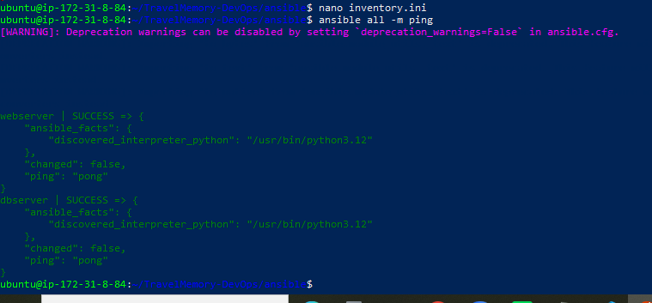
Database Ansible playbook
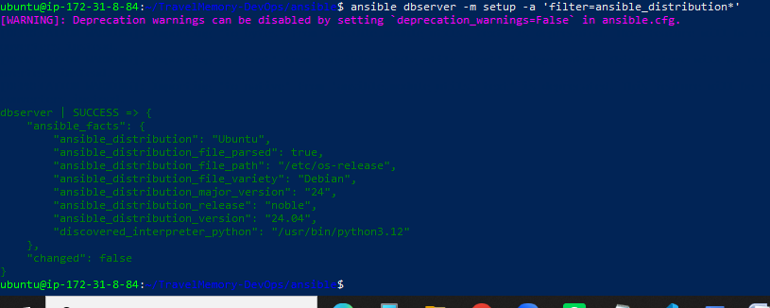
Web server Ansible playbook: Configured
• Git
• Curl
• Nginx
• Node.js 20
• npm
• Nginx enabled and started
Then Clone the Repository: see scrrenshot for ref
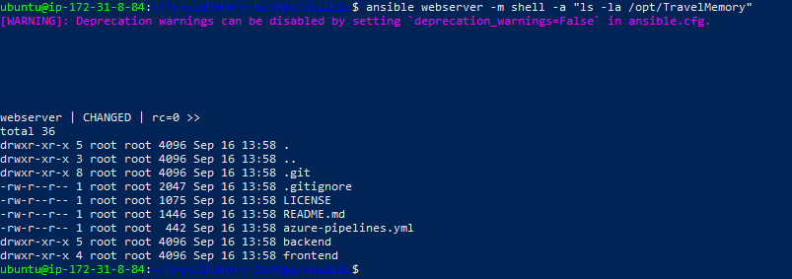
- Install frontend dependencies
- Install backend dependencies
- Configure MongoDB environment
- Verify MongoDB version
- Verify MongoDB is enabled at boot
- Verify the DB private IP
- Check MongoDB listening address
Now the Project Structure flow: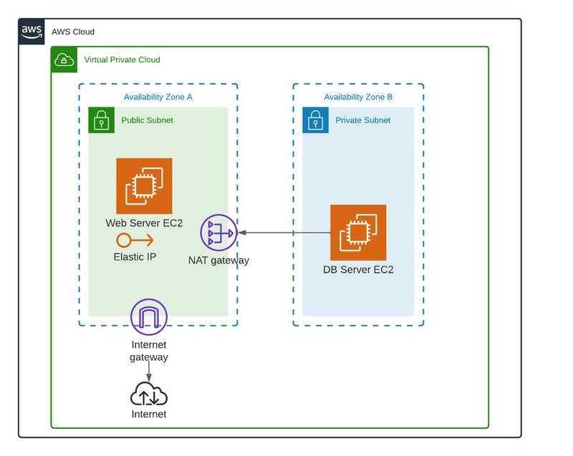
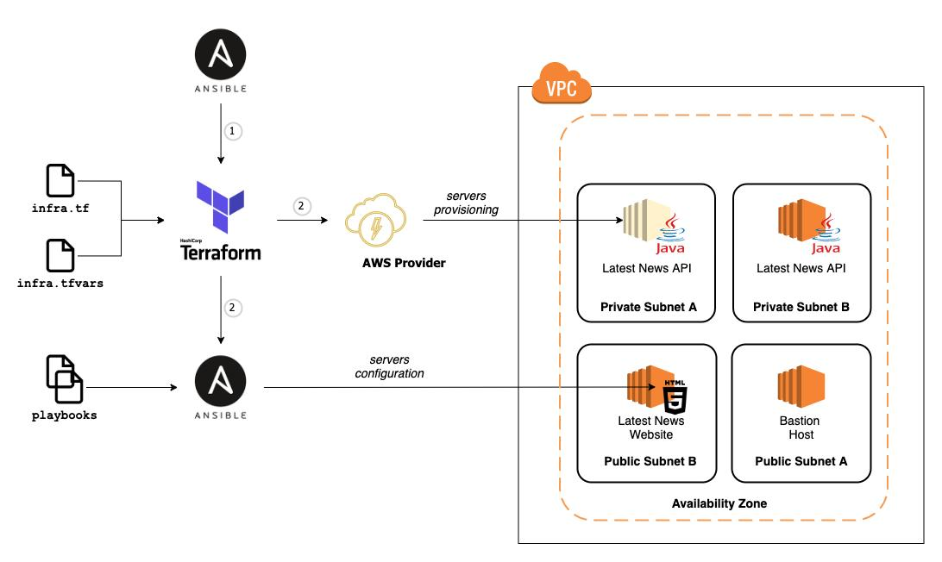
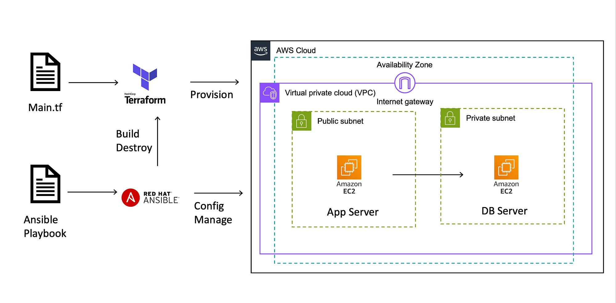
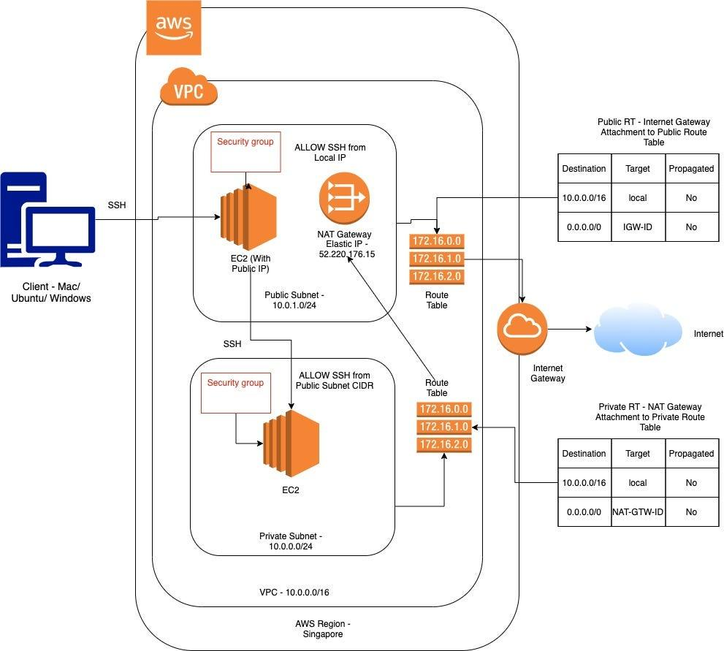

Now MOngoDB is Succesfully installed. The DB remains private; only the Web EC2 should be able to reach MongoDB.We should do this through Ansible, because your assignment is specifically Terraform + Ansible.
Configure MongoDB bind IP:
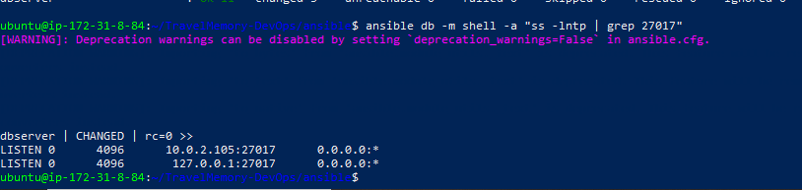

Configure the AWS Security Group
Now we need to allow only the Web EC2 to connect to MongoDB.
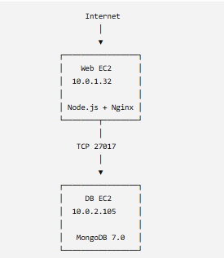

1. Find your DB Security Group ID
From your Ubuntu control EC2, run:
aws ec2 describe-instances \
--instance-ids i-08ac6c8dac25418f9 \
--query 'Reservations[0].Instances[0].SecurityGroups[*].[GroupId,GroupName]' \
--output table
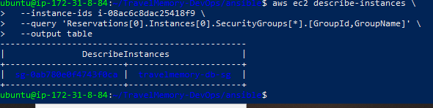

2. Find your Web Security Group ID
Run:
aws ec2 describe-instances \
--instance-ids i-0f0113b709cd87ad3 \
--query 'Reservations[0].Instances[0].SecurityGroups[*].[GroupId,GroupName]' \
--output table
This gives us the Web SG.
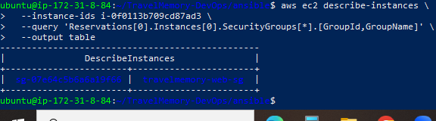

Step 1 — Check the DB Security Group first

You are already in the correct terminal:
ubuntu@ip-172-31-8-84:~/TravelMemory-DevOps/ansible$

aws ec2 describe-security-groups \
--group-ids sg-0ab780e0f4743f0ca \
--query 'SecurityGroups[0].IpPermissions' \
--output json
This will show the current inbound rules of the MongoDB Security Group.
The Web EC2 can successfully connect to MongoDB.
Connection to 10.0.2.105 27017 port [tcp/*] succeeded!
confirms:
- Web EC2: 10.0.1.32
- DB EC2: 10.0.2.105
- MongoDB: 27017
- Security Group communication:
- Network connectivity:
- MongoDB service:
The infrastructure/network portion is working.
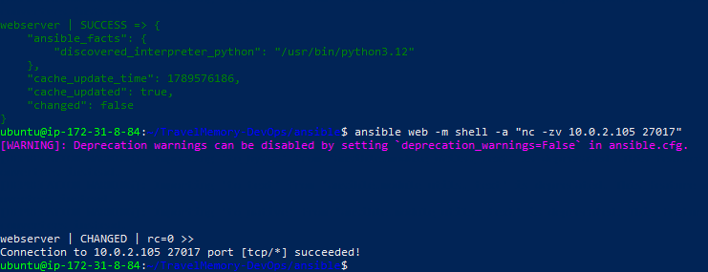
Configure MongoDB Authentication

Step 1 — Create an Ansible Vault password file

- ~/TravelMemory-DevOps/ansible
- mkdir -p group_vars/db
Then create the encrypted Vault file:
ansible-vault create group_vars/db/vault.yml
It will ask:
New Vault password:
Confirm New Vault password:

Choose a password you can remember
This is the Ansible Vault password, not the MongoDB password.
After entering it, an editor will open.
If it opens in nano, enter:
mongodb_app_password: "TravelMemory@2026#DB"

Step 2 — Verify the Vault file exists
ls -l group_vars/db/

Step 3 — Create the MongoDB application user
Before enabling authentication, MongoDB currently allows local access without credentials.
We'll use mongosh on the DB server to create the user.
ansible db -m shell -a 'mongosh --quiet --eval '\''db = db.getSiblingDB("admin"); db.createUser({user:"travelmemory_user", pwd:"TravelMemory@2026#DB", roles:[{role:"readWrite", db:"travelmemory"}]})'\'''

Current status
Ansible Vault :Working
Vault variable :mongodb_app_password
db.yml syntax :Valid
MongoDB :Running
MongoDB port 27017 :Reachable from Web
Security Group :Web → DB only
Now we can actually create the TravelMemory MongoDB user.

1. First verify MongoDB authentication configuration
Run this with the Vault password:
ansible db -m shell -a "grep -A3 '^security:' /etc/mongod.conf" --ask-vault-pass
Then:
ansible db -m shell -a "systemctl is-active mongod" --ask-vault-pass
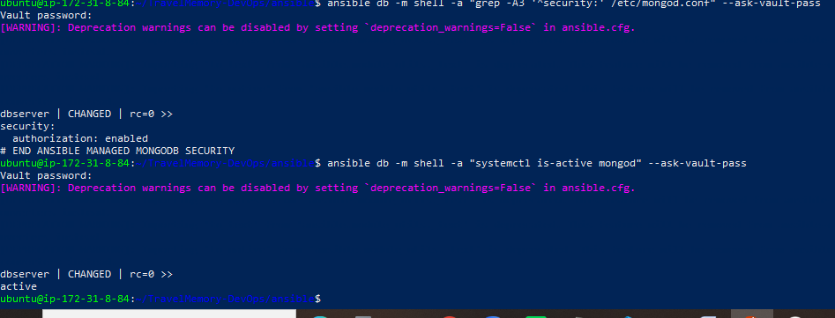

Perfect. The output confirms the backend and frontend structure. There is one important issue we should fix before building:
- Backend runs on port 3000.
- Frontend currently defaults to port 3001.
- Your backend actually exposes /trip.
- We can avoid exposing port 3000 publicly by having Nginx proxy /trip → backend port 3000.
- The frontend can then use a relative URL such as /api or /trip.
Because the frontend currently uses REACT_APP_BACKEND_URL, we can configure it during the React build without modifying the application source.

Step 1 — Check the complete frontend URL file
You are currently on the Control EC2:
~/TravelMemory-DevOps/ansible

ansible web -m shell -a "cat /opt/TravelMemory/frontend/src/url.js"
Also check the frontend package configuration:
ansible web -m shell -a "cat /opt/TravelMemory/frontend/package.json"
And check whether the frontend uses a build directory after a previous build:
ansible web -m shell -a "ls -la /opt/TravelMemory/frontend"

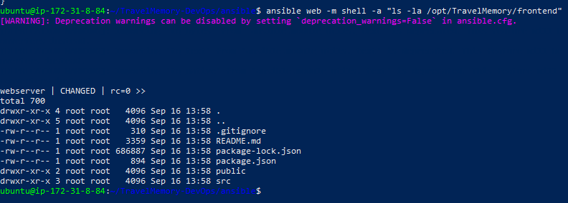

Therefore, we'll use Nginx as the single public entry point:
Browser
|
| http://13.207.190.203
v
Nginx :80
|
+---- /trip/* ----> Node.js :3000
|
+---- /* ---------> React build
The browser will not need to access port 3000 directly.

